Moody Gardens non-collection animal policy

**Non-Venomous:**

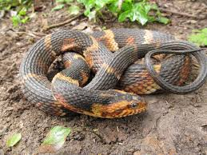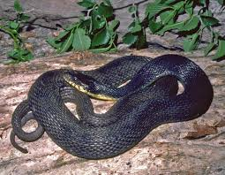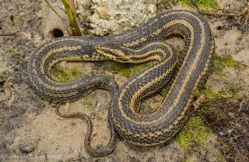

Water snakes various species, *Nerodia sp.*, colors and patterns may vary

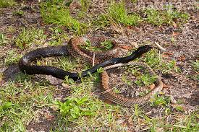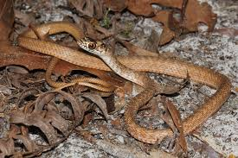

Eastern coachwhip, *Masticophis flagellum,* juvenile on the right, colors may vary

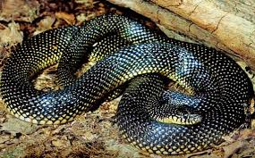 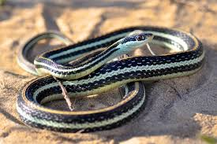

Speckled kingsnake, *Lampropeltis holbrooki* Eastern garter snake, *Thamnophis sirtalis sirtalis*

**Venomous:**

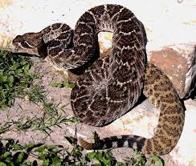

Western Diamondback rattlesnake, *Crotalus atrox*

* The venomous snake species that would most likely be encountered on property is a diamondback rattlesnake. They are obvious and distinguishable from other snakes because of the rattle on their tail.
* Snakes are often misunderstood in that people think they are ‘coming after them’. Snakes are **NOT** dangerous when they are left alone.
* Curatorial will come move any snake that may be impeding work that needs to be done or if a venomous snake is in a very public space. We will try to move snakes for their own safety and protection as much as for the protection of our guests. Non-venomous snakes will be moved off pathways if they are causing an issue for the public.
* Snakes are beneficial- they are rodent and pest control and are indicators of a healthy habitat. Keeping your outside areas free of clutter helps deter them from being in that area.
* Remember, the more a snake is poked, prodded at, the more dangerous it is and the more likely a bite could occur. Bites to humans from cats and dogs are way more medically significant than that of a non-venomous snake.

**Protocol**

* If a snake is seen and it is prohibiting a job being done (found in some pipe or in the shrubs being watered for example) call for Rainforest Curatorial. We don’t currently have a code for this but announce that you need assistance moving an animal and they should bring hooks and a bucket.
* Curatorial will come and attempt to move if it is deemed necessary.
* Please do not try to move the snake yourself or use any objects or force to kill the snake. We are a CONSERVATION organization and part of meeting our mission is making sure that we are not unnecessarily killing animals.

**Other Wildlife**

* Injured birds- please call Rainforest curatorial and we will attempt to capture the bird. Please designate that you need help with an animal and need a net and crate. We work closely with Galveston Animal Services in order to get wildlife to a rehab facility. *Please note that we will try to assist with birds that are trapped in buildings, but there are often things that can be done without curatorial assistance.
* Migratory songbirds. We are on a migratory route and twice a year we have a lot of native songbirds passing through Galveston. We do have some known spots where we have seen window strikes. Please also alert Rainforest curatorial as we keep a database of the bird species and the location.
* Raccoons, possums, feral cats are all the same procedure as birds. We will attempt to capture if the animals are posing a potential risk to their own safety or the guest safety. We will attempt to capture via traps and get them to the animal shelter or rehabber.
* Coyotes- we do not attempt to capture or trap them. It is nice to know if you see any on property for general tracking purposes. Moody Gardens houses animals out doors in various locations and knowing where coyotes are is helpful.

**Curatorial Staff is always happy to meet and talk with departments if there are questions or concerns about the local wildlife on property.